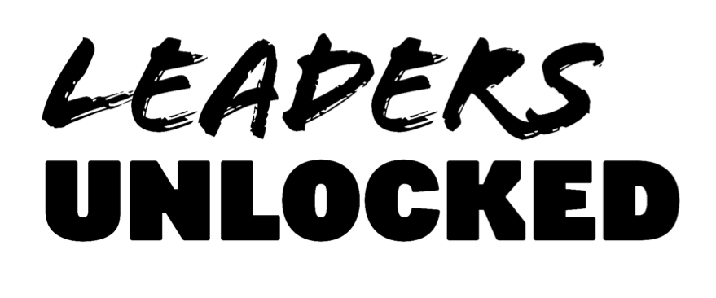
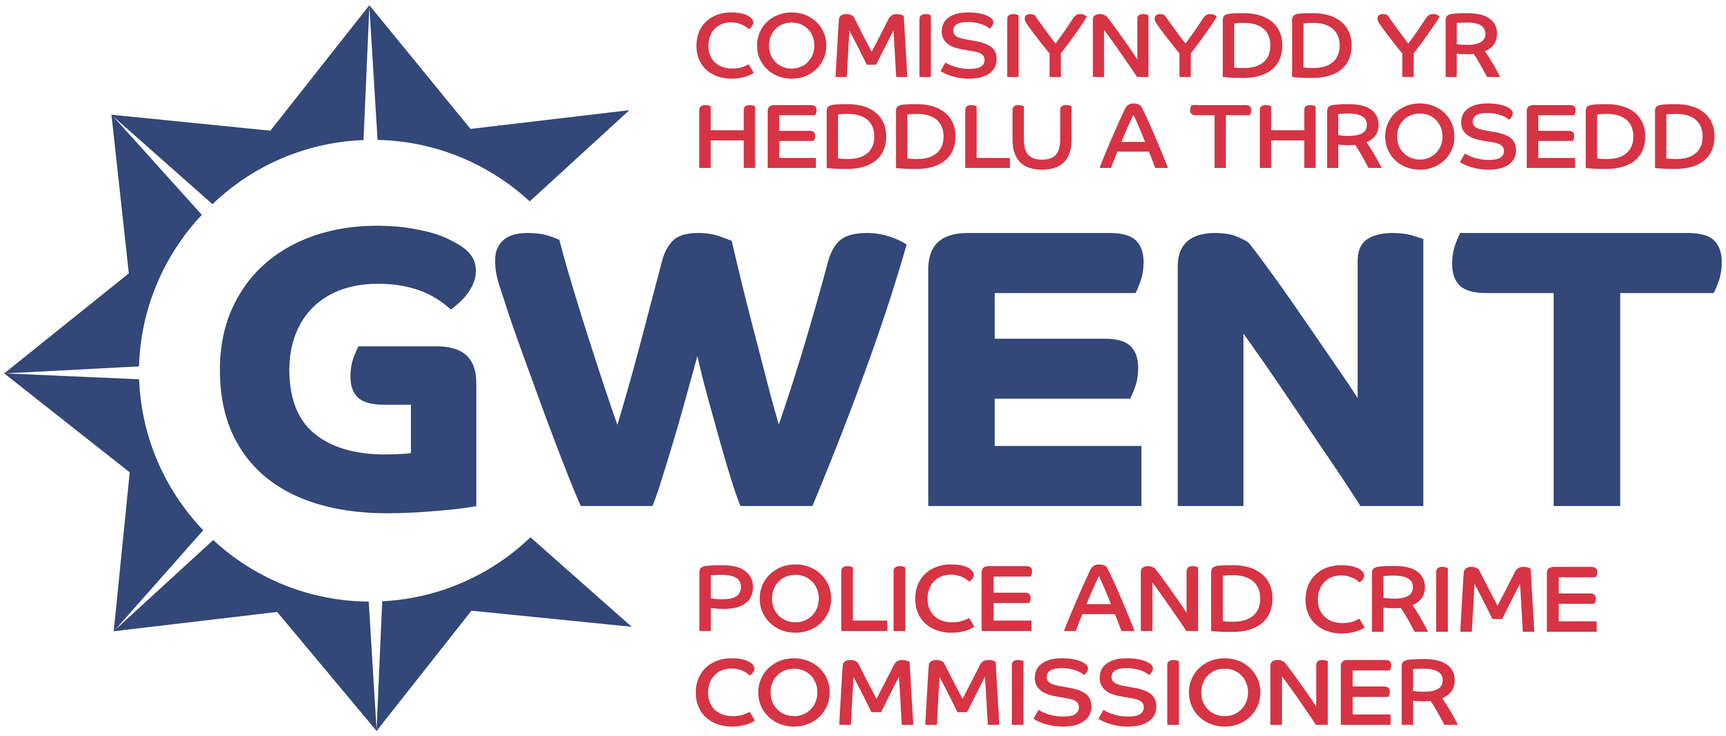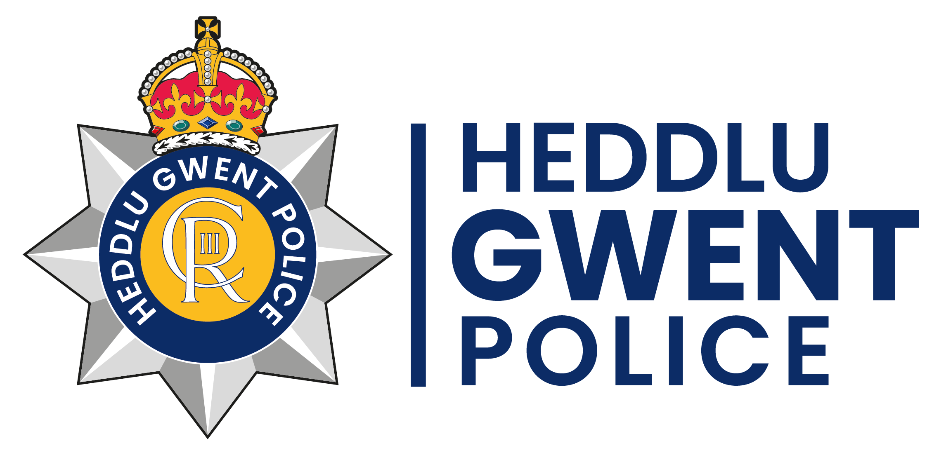
Gwent Youth Independent Advisory Group (YIAG) 2025/2026
CONSENT FORM
If you are under 18, please ask a parent/guardian/carer to complete and sign this form. Please make sure they have read the Application Guidance Notes and understand what’s involved in the project.

I consent to [NAME] ………………………………………………………………………………………… becoming a member of the Gwent Youth Independent Advisory group (YIAG).
Parent/guardian name (PRINT) …………………………………………………………………………………………………………………
Parent/guardian signature………………………………………………………………………………………………………………………..
Relationship to applicant …………………………………………………………………………………………………………………………
Date…………………………………………………………………………...................................................................................
Contact telephone number……………………………………………………………………………………………………………………….
E-mail……………………………………………………………………………………………………………………………………………………….

This form can be photographed/scanned and emailed to Ada@leaders-unlocked.org Before or at the first members meeting on Saturday 25th October 2025.
Your privacy is really important to us. By filling in this application form, you are consenting to both Leaders Unlocked and Gwent Police using your personal information to keep in touch with you over the course of this project. If your application is not successful, or you decide to withdraw your application, we will delete your personal data from our files. We will not share your data with people outside of the project team.

If you want to withdraw your consent at any time you can contact the Data Protection Officer at info@leaders-unlocked.org.
To read the Leaders Unlocked privacy policy, please click here.
To read the Gwent Police privacy policy, please click Privacy Notice | Gwent Police

