
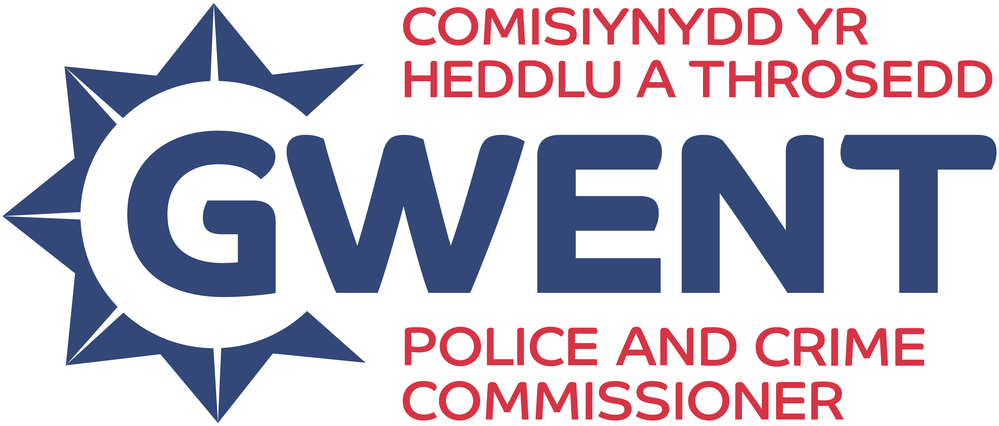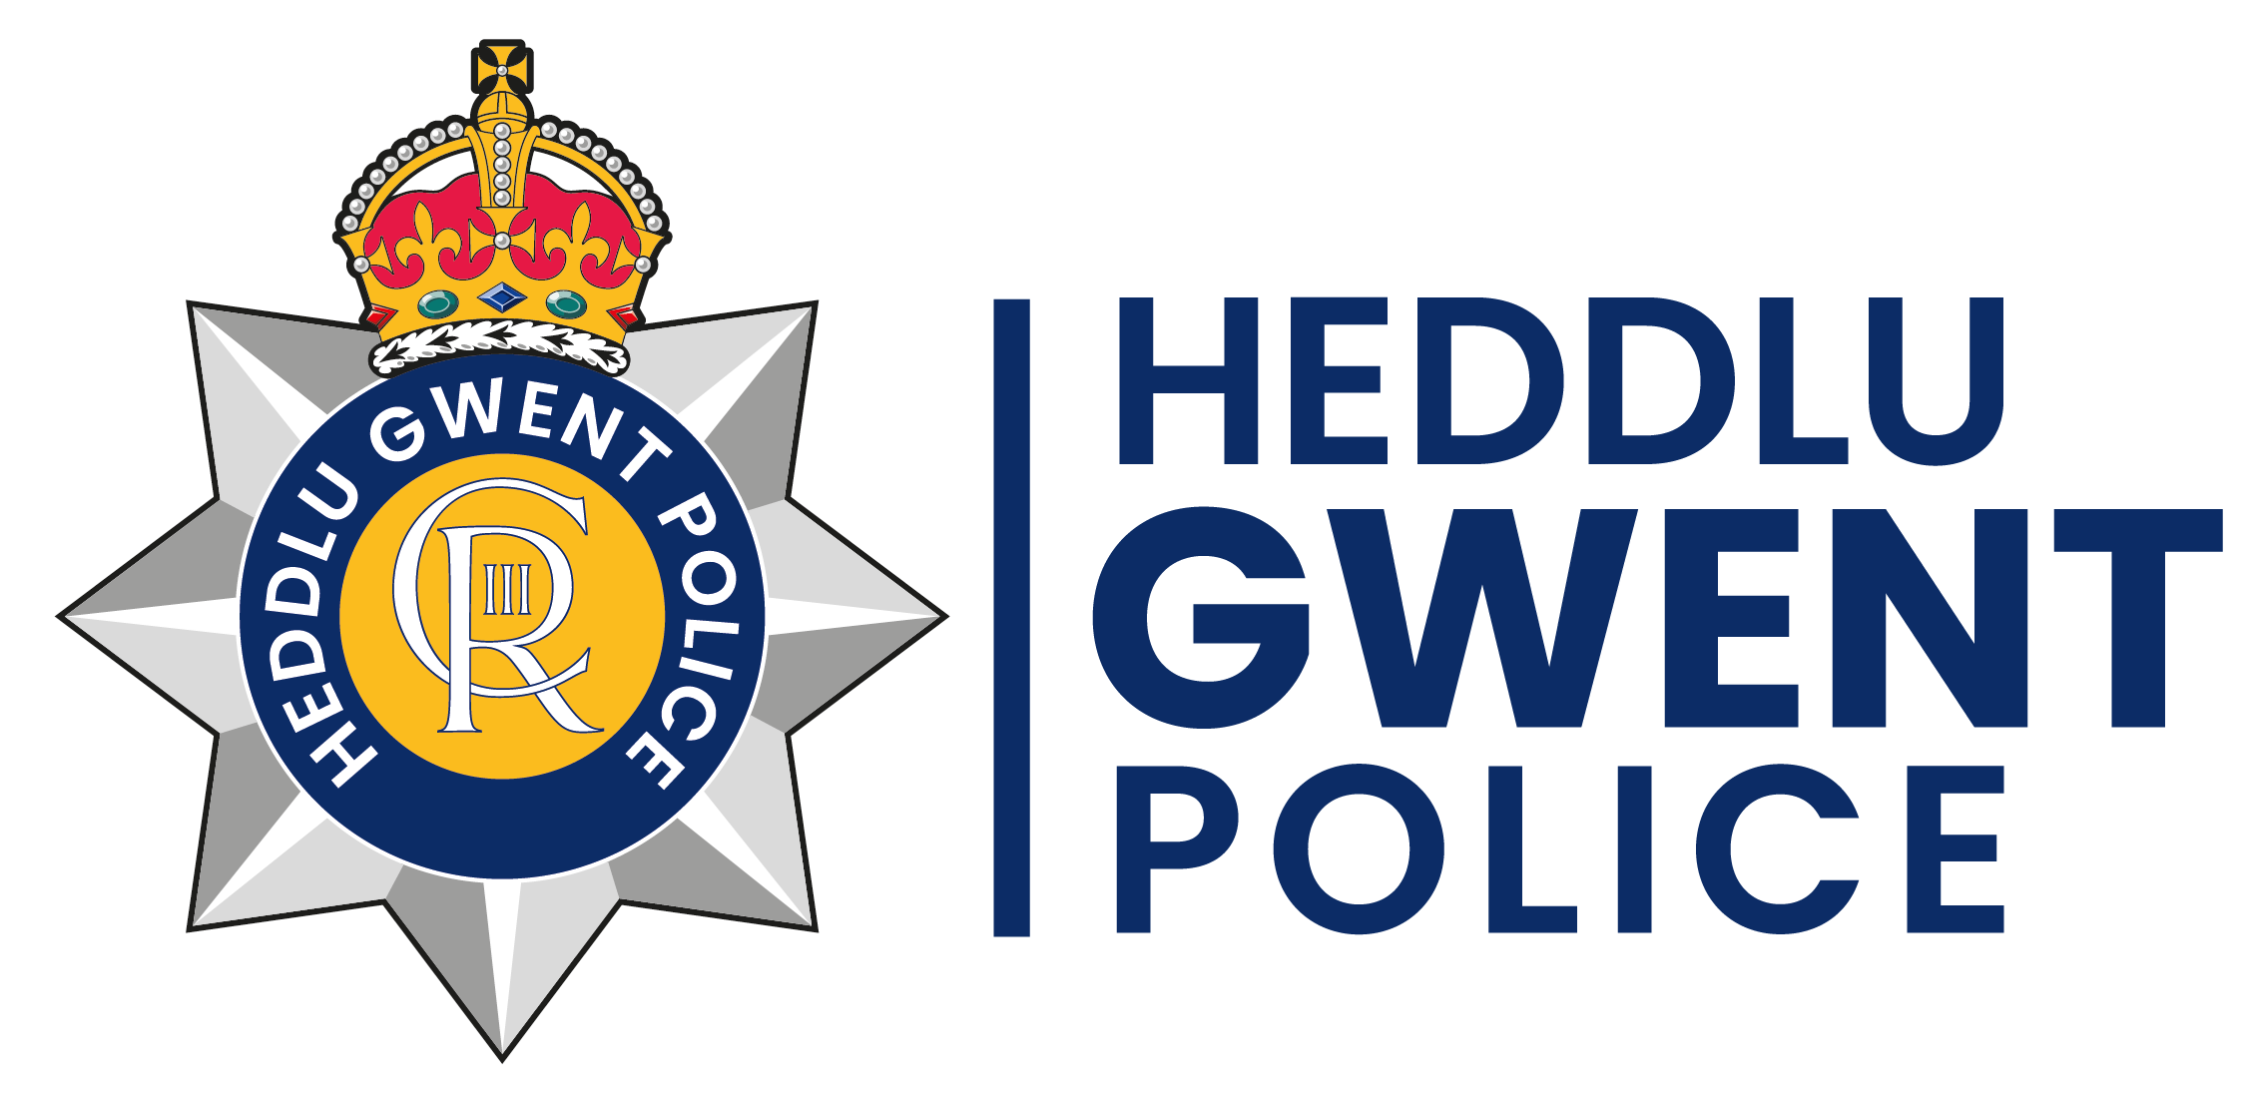

Gwent Youth Independent Advisory Group 2025:
Application Form

We are looking for applications from 14-25-year-olds who are currently residents across the local authorities of Gwent: Newport, Monmouth, Caerphilly, Torfaen, and Blaenau Gwent.
We want to hear from all sections of our community and will do our very best to make sure nothing is a barrier to your attendance. Travel expenses will be reimbursed to ensure all members can participate without cost barriers.
Purpose of the Youth Independent Advisory Group:
The Youth Independent Advisory Group (YIAG) provides young people with a platform to share their views with Gwent Police, get involved in looking at what the police do and why, and influence decisions that affect their communities. Members are expected to attend around 6 meetings per year, actively contributing to discussions and providing feedback.
You can read more about what the youth IAG will do in our guidance notes: https://leaders-unlocked.org/gwent-youth-independent-advisory-group-yiag/
Section 1: Your details

NAME:

DATE OF BIRTH:
HOME ADDRESS:
POST CODE:
EMAIL:
LANDLINE:
MOBILE:

If you are selected, we would like the ability to be able to connect with you via social media. Please provide your social media handles below.

FACEBOOK:
Instagram:

CURRENT OCCUPATION (Student at school, college, university, in work, unemployed):

NAME OF YOUR SCHOOL/ COLLEGE/ UNIVERSITY/ YOUTH ORGANISATION/EMPLOYER ORGANISATION:

NAMED PROFESSIONAL WHO WOULD SUPPORT YOUR APPLICATION AND THEIR ORGANISATION (This could be a teacher, youth worker, tutor, lecturer, manager):
Name and contact details:

If you are under 18 years old, please ask your parent/guardian/carer to provide the following details too. We will require written permission from them before we can confirm your place.

NAME OF PARENT/GUARDIAN/CARER:
HOME ADDRESS:
POST CODE:
EMAIL:
LANDLINE:
MOBILE:

Section 2: More about you

- Why do you want to join the Gwent Youth Independent Advisory Group?

- Why do you think you should be selected for the Gwent Youth Independent Advisory Group?
For example, you might have specific skills, knowledge or life experiences that you’d like us to know about.

- Please tell us about yourself. Use up to 50 words to sum up your personality, interests, or strengths. (Please stay within the word limit.)

Section 3: Your availability

We will be holding the first meeting on Saturday, 25th October 2025 (location to be confirmed).

Are you available to attend? Yes [ ] No [ ]

Section 4: Diversity monitoring information

Leaders Unlocked and the Gwent Police and Crime Commissioner are committed to promoting equality and diversity. We invite you to complete this section of the application form so that we can monitor and analyse information about the diversity of the people who submit an application. Any information you provide will be treated as strictly confidential. It will not be shared or used by anyone directly involved in the selection process. We will transfer all the information provided into a database and then destroy all individual forms. No information will be published or used in any way that allows any individual to be identified. You are not obliged to answer the questions on this form. If you do not wish to answer a question simply answer ‘Prefer not to say’.

- Your Gender (please put an X in the appropriate box)

Male Female Prefer not to say

- Gender Identity Does your gender differ from the biological sex you were assigned at birth?
Yes No Prefer not to say

- What is your preferred pronoun?

He/Him She/Her They/Them Xe/Xim Other

- Your sexual orientation (please put an X in the appropriate box)

Bisexual Gay man Gay woman/lesbian

Heterosexual Other Prefer not to say

- Your religion or belief (please put an X in the appropriate box)

None Buddhist Christian

Hindu Jewish Muslim

Sikh Any other Prefer not to say

- Your ethnic origin (please put an X in the appropriate box)

Asian/Asian British

Bangladeshi Chinese Indian Pakistani

Any other Asian background

Black/African/Caribbean/Black British

African Caribbean

Any other Black/African/ Caribbean background

Other ethnic groups

Arab Any other ethnic group Prefer not to say

Mixed/multiple ethnic background

White and Black Caribbean White and Black African

White and Asian Any other/ multiple ethnic background

White

British English Welsh Scottish

Northern Irish Gypsy or Irish Traveller Other

- Do you consider that you have a disability (including neurodiversity)

Yes No Prefer not to say

- Do you have any additional support needs e.g. food allergies/travel

Yes No Prefer not to say

Section 5: When will I hear back?

We will conduct interviews with shortlisted candidates by either phone, Teams or Zoom (whichever you prefer). All successful applicants will be informed by 20th October 2025
If you have any other questions about the application process, please email Kaytea Budd-Brophy at Kaytea@leaders-unlocked.org

Please email your application forms back by Friday 10th October 2025 to:
Ada@leaders-unlocked.org

Section 6: How will you protect my privacy?

Your privacy is really important to us. By filling in the Gwent Youth Independent Advisory Group application form, you are consenting to Leaders Unlocked using your personal information to keep in touch with you over the course of the project. If your application is not successful, or you decide to withdraw your application, we will delete your personal data from our files.

If you want to withdraw your consent at any time you can contact the Data Protection officer at info@leaders-unlocked.org and if you would like to see our full Privacy Notice you can do so here http://leaders-unlocked.org/wp-content/uploads/2018/05/Leaders-Unlocked-Privacy-Notice-May-2018-1.pdf

We look forward to receiving your application!

