
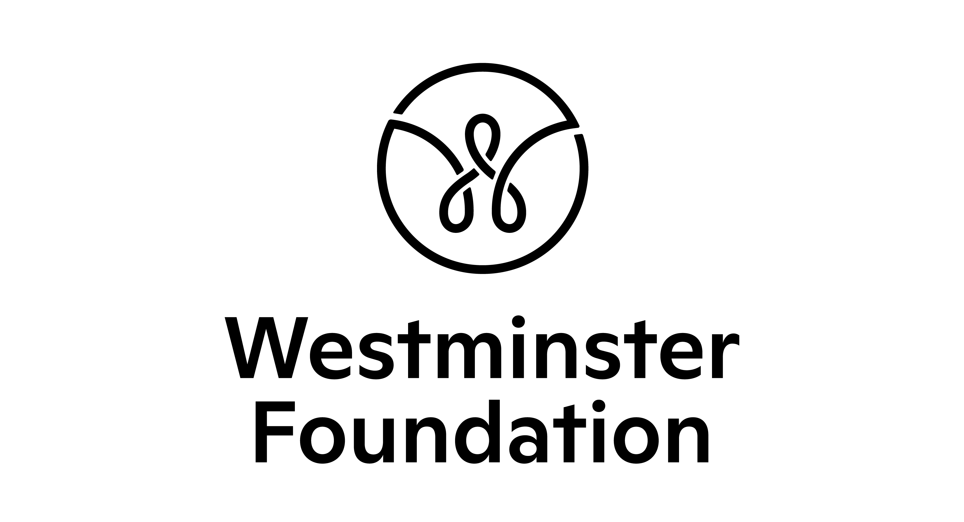


Opportunity for 14–24-year-olds in Chester and Ellesmere Port: Join a Youth Voice panel to help make decisions about funding in your local area!

Application form

We are looking for applications from 14–24-year-olds who are currently living in Chester or Ellesmere Port.

Section 1: Your details

Name:

Date of birth:

Age:

Home address:
Postcode:

Email:

Phone:

Name of your school/college/youth organisation/employer (if you have one):

Name and contact details of a professional who would support your application (if you’re not sure, leave this blank and we can discuss it at the next stage):

If you are under 18, please ask your parent/guardian/carer to provide the following details. We will require written consent from them before we can confirm your place.

Name of parent/guardian/carer:

Home address:

Postcode:

Email:

Landline:

Mobile:

Section 2: Different ways to apply

There are different ways to apply for the Youth Voice Panel. Please select one of the options below:

In writing – please provide your written answers below in section 3

By video – please send us a short video to respond to the questions in section 3

By phone – if you select this option, one of our team will get in touch with you by phone to guide you through the questions and gather your responses

Any video files should be emailed to gabrielle@leaders-unlocked.org and should have your name in the title. If the files are too big to send as attachments, please use ‘We Transfer’ to transfer them.

Section 3: Written answers

If you would like to apply in writing, please write your answers below.

- Why do you want to join the Youth Voice Panel?

- If we asked those who know you best, what would they say you could offer as a panel member? You might have skills, knowledge, or life experiences that you’d like to tell us about.

- In your opinion, what problems are children and young people facing in Chester or Ellesmere Port?

Section 4: Diversity monitoring information

Leaders Unlocked and the Westminster Foundation are committed to promoting equality and diversity. We ask you to complete this form so that we can monitor information about the diversity of the people who apply. Any information you provide will be treated as strictly confidential. We will transfer all the information provided into a secure database and then destroy all individual forms. No information will be published or used in any way that allows any individual to be identified. You are not obliged to answer the questions on this form. If you do not wish to answer a question simply answer ‘Prefer not to say’.

- Your gender (please put an X in the appropriate box)

Male Female Non-binary

Prefer not to say

If you prefer to use your own term, please specify here:

- Your pronouns (please put an X in the appropriate box)

She/her He/him They/them

Other Prefer not to say

If you prefer to use your own term, please specify here:

- Your religion or belief (please put an X in the appropriate box)

None Buddhist Christian

Hindu Jewish Muslim

Sikh Prefer not to say

If other religion or belief, please write in:

- Your ethnic origin (please put an X in the appropriate box)
White

British English Welsh Scottish

Northern Irish Gypsy or Irish Traveller Other

Any other white background, please write in:

Mixed/multiple ethnic background

White and Black Caribbean White and Black African

White and Asian

Any other mixed background, please write in:

Asian/Asian British

Bangladeshi Chinese Indian Pakistani

Any other Asian background, please write in:

Black/African/Caribbean/Black British

African Caribbean

Any other Black/African/Caribbean background, please write in:

Another ethnic group

Arab Prefer not to say

Any other ethnic group, please write in:

- Do you consider that you have a disability or additional need?

Yes No Prefer not to say

- Have you ever received free school meals?

Yes No Prefer not to say

The information in this form is for monitoring purposes only. It will not be used to assess your application. If you need support during the recruitment process or to be a Youth Panel member, we can discuss this with you. Please reach out to Gabrielle at Leaders Unlocked who is coordinating the recruitment process (gabrielle@leaders-unlocked.org).

Section 5: What are the next steps?

Please email your application form (and any supporting file if applying by video) to gabrielle@leaders-unlocked.org by Sunday 27th July 2025. If you have any questions, please email gabrielle@leaders-unlocked.org

Section 6: How will you protect my privacy?

Your privacy is really important to us. By filling in this application form, you are consenting to Leaders Unlocked and the Westminster Foundation using your personal information to keep in touch with you over the course of this project. If your application is not successful, or you decide to withdraw your application, we will delete your personal data from our files. We will not share your data with people outside of the project team.

If you want to withdraw your consent at any time you can contact the Data Protection officer at info@leaders-unlocked.org.

To read our privacy statement please go to https://leaders-unlocked.org/luwp/wp-content/uploads/2024/12/Leaders-Unlocked-Privacy-Notice-2024.pdf

We look forward to receiving your application!

