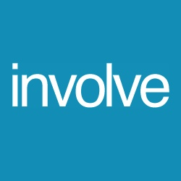
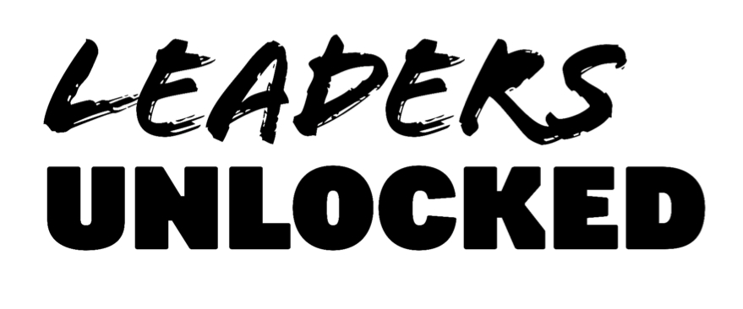

MH:2K CENTRAL LANCASHIRE: CONSENT FORM FOR UNDER-18s
If you are under 18, please ask a parent/guardian/carer to complete and sign this form. Please show them the Application Guidance Notes to ensure they understand what the project involves.

I consent to [NAME] ………………………………………………………………………………………… becoming a member of MH:2K Central Lancashire from October 2017 to May 2018.

Parent/guardian name (PRINT) ……………………………………………………………………………………………………

Parent/guardian signature………………………………………………………………………………………………………….

Relationship to applicant ……………………………………………………………………………………………………………

Date…………………………………………………………………………......................................................................

Contact telephone number………………………………………………………………………………………………………....

E-mail…………………………………………………………………………………………………………………………………………..

This form can either be submitted at the first event or scanned and emailed to kaytea@leaders-unlocked.org

